##### **1. Home Page**

* • Professional headshot/picture of yourself
* 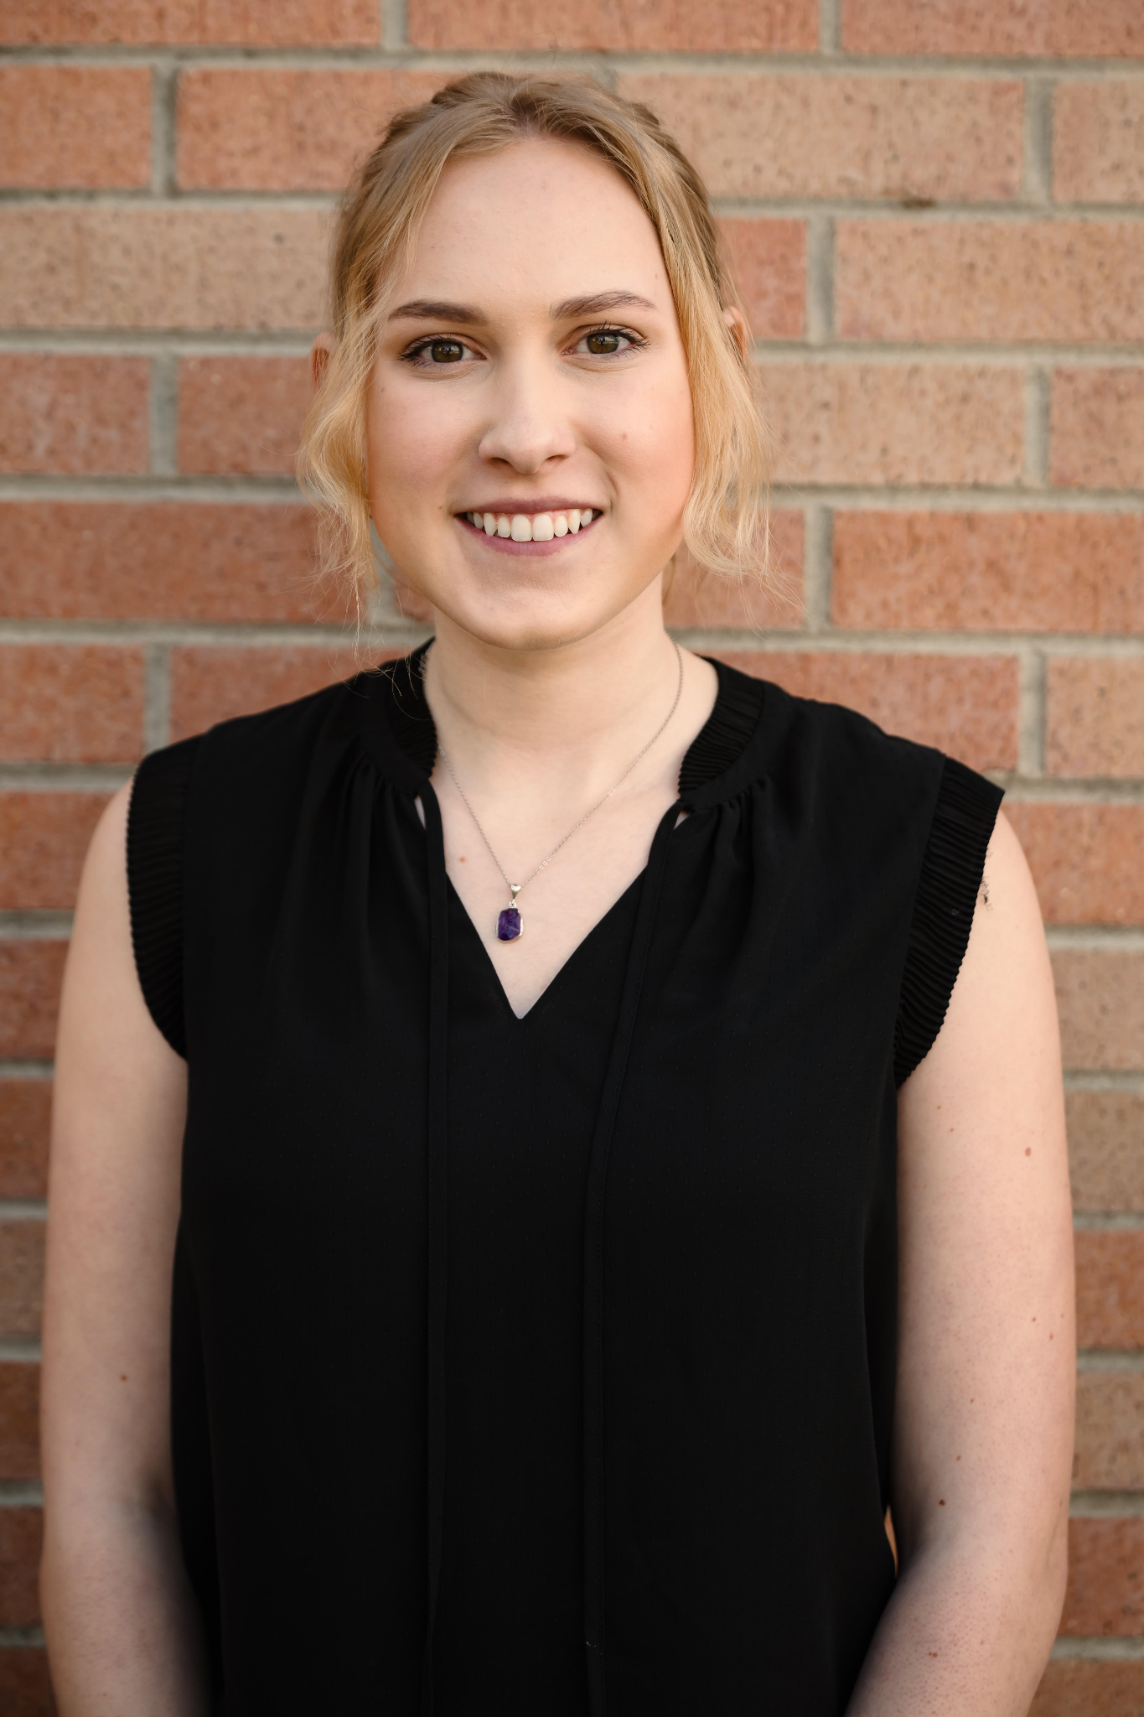
* • Two hobby summaries with accompanying pictures
* 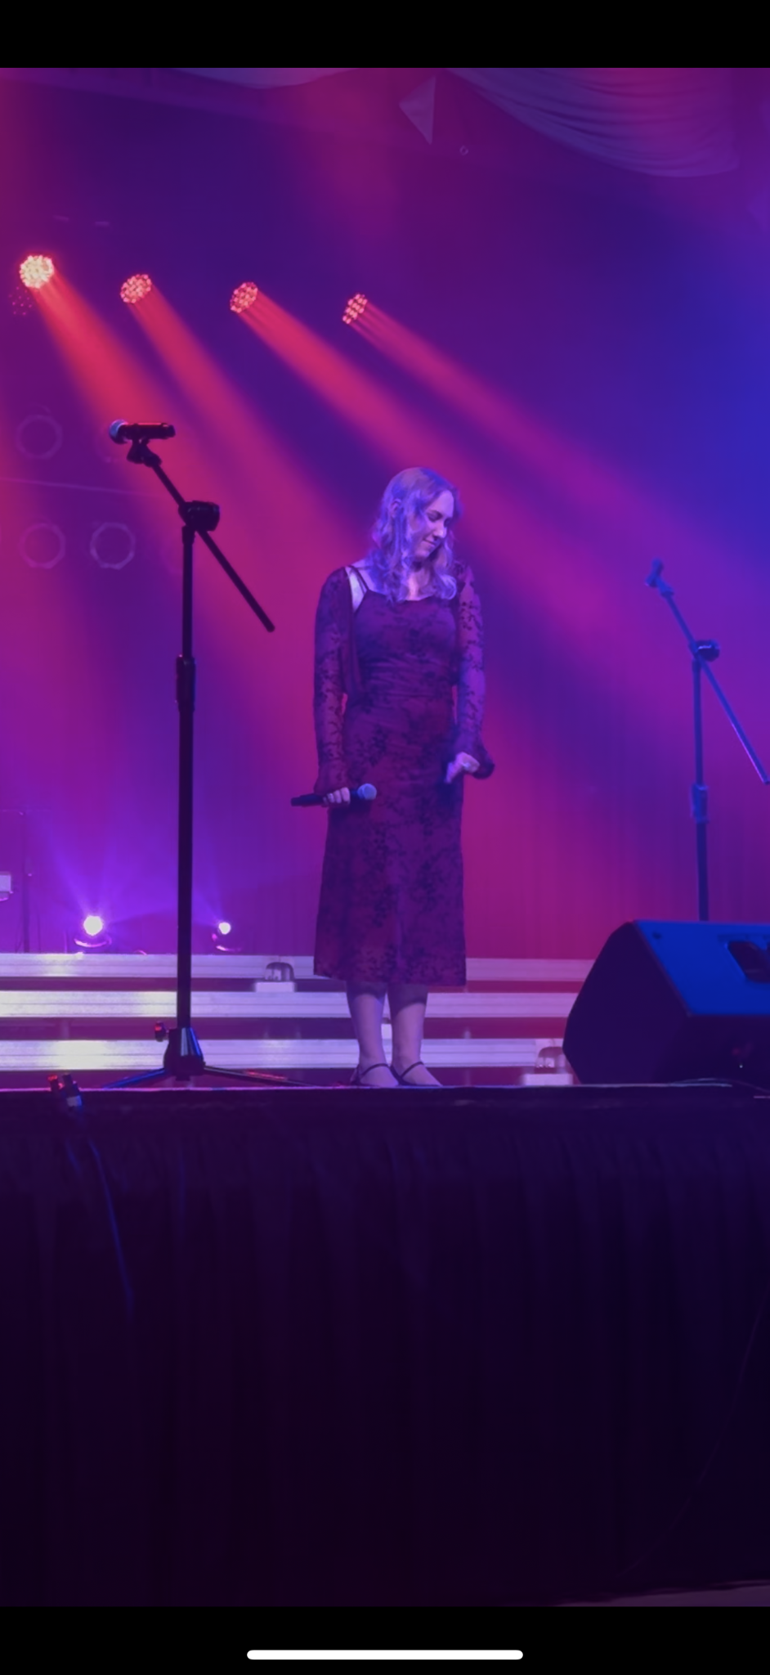
* I have been performing since I was three years old within theater, choir, and many select singing groups, including 8th grade select choir, Wavelength Jazz Choir, and Lake Effect Jazz Choir. I love performing in big groups as well as solo. I have sung in many languages including French, Italian, Latin, and Spanish.
* 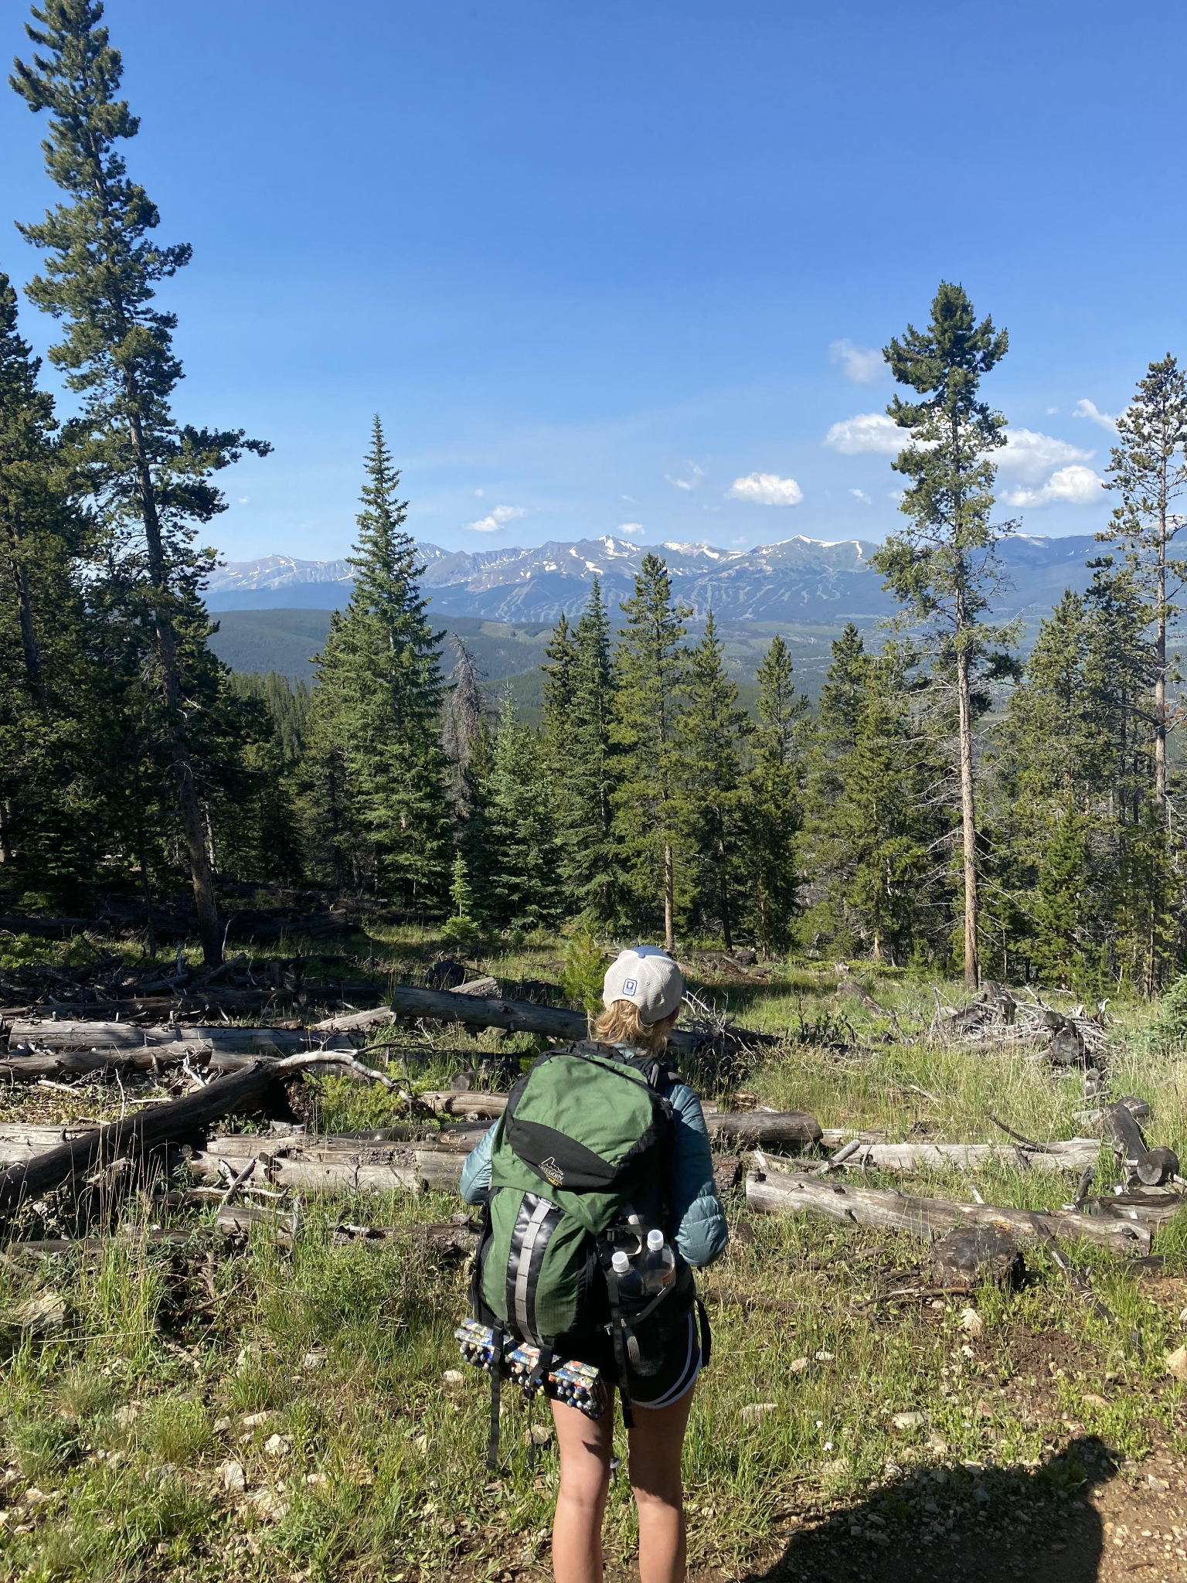
* I love to hike and spend time in nature. Me and my dad will go on backpacking trips together and also I love to take any opportunity I can to get out onto a trail. I am very interested in sustainability and try to be an advocate for it. I have adopted a vegan lifestyle as I am trying to do my part in reducing methane emissions.
* • Short welcome video for visitors (introduce yourself)
* • Professional introduction and overview
* Psychology major and business minor interested in management, research, and potentially pre-med. Hi, I’m Hannah and I am a freshman at UMD. I have many goals and interests which I am currently working towards, but a general theme is that I want to work with people to help them live a more healthy and sustainable lifestyle. I am a big advocate of personal development and living in a way which gives you a high quality of life. I have a holistic approach focussing on the interconnected health of the mind, body, and spirit.

##### **2. Hobbies Page**

* • Detailed descriptions of your hobbies and favorite activities
* I have many hobbies. I love to cook/bake, and usually everything I make is vegan because two years ago I adopted a vegan lifestyle. I am very active and enjoy going to the gym, and was also on my high school's swim team. I am a proud theater kid, you can always find me on a stage whether I’m in a musical or singing. On a rainy day I love to curl up on the couch with a cup of tea and a good book. You might catch me crocheting, painting, or doing any other craft imaginable. On the other side of that, I also enjoy some adrenaline every once in a while, such as skydiving or outdoor rock climbing.
* • Minimum of three pictures showcasing your interests

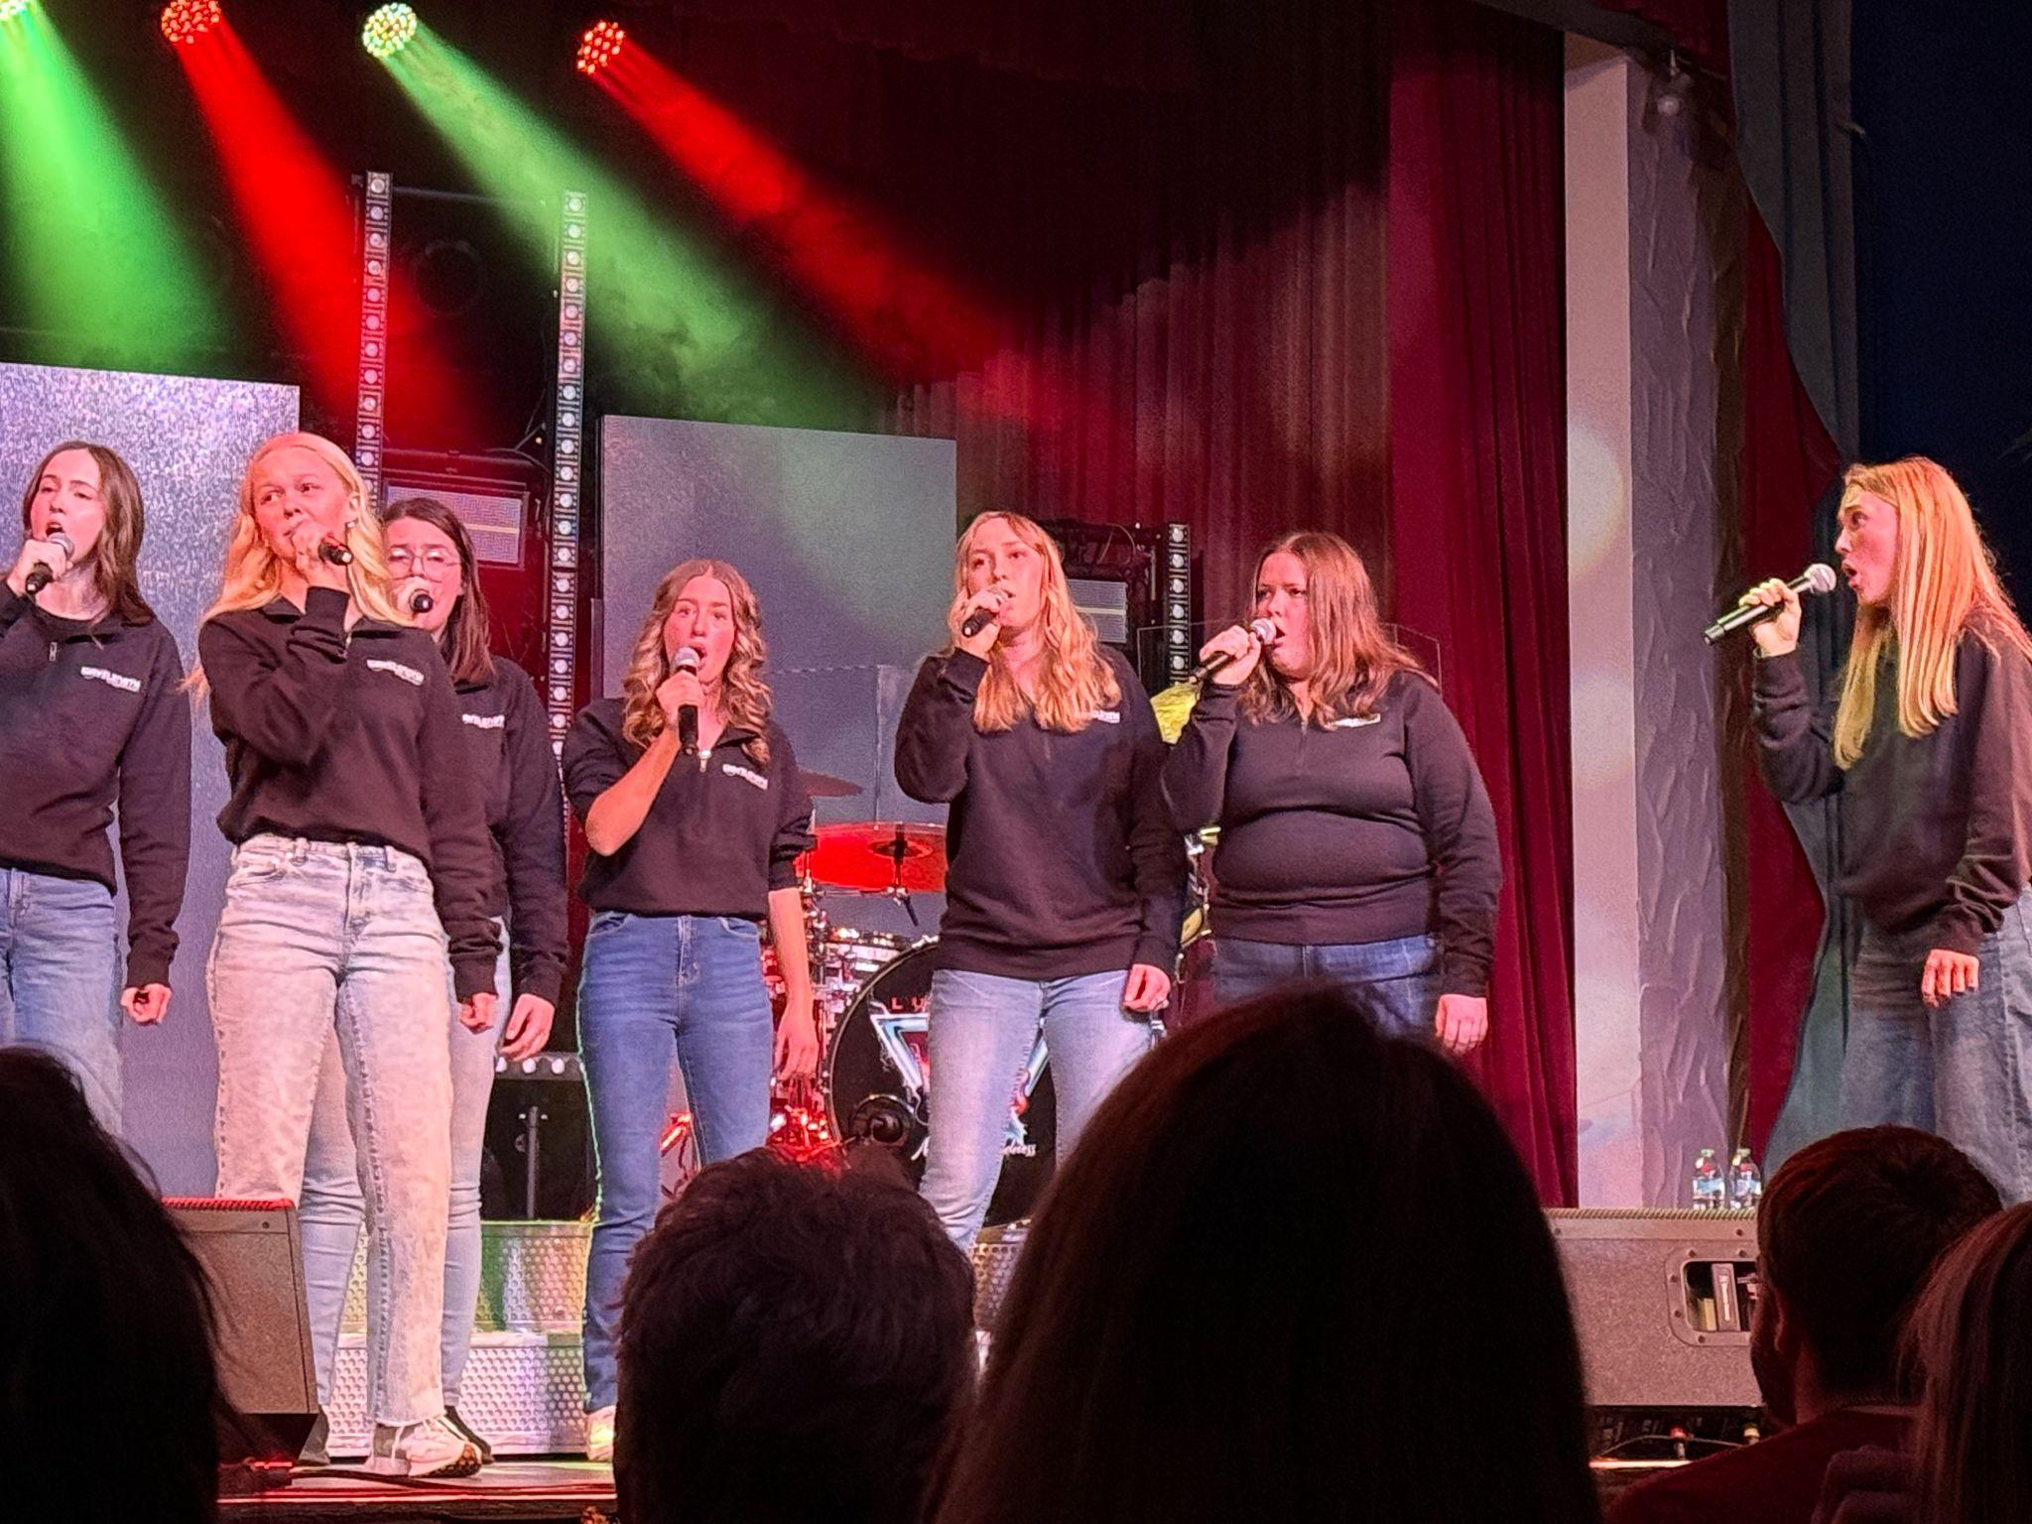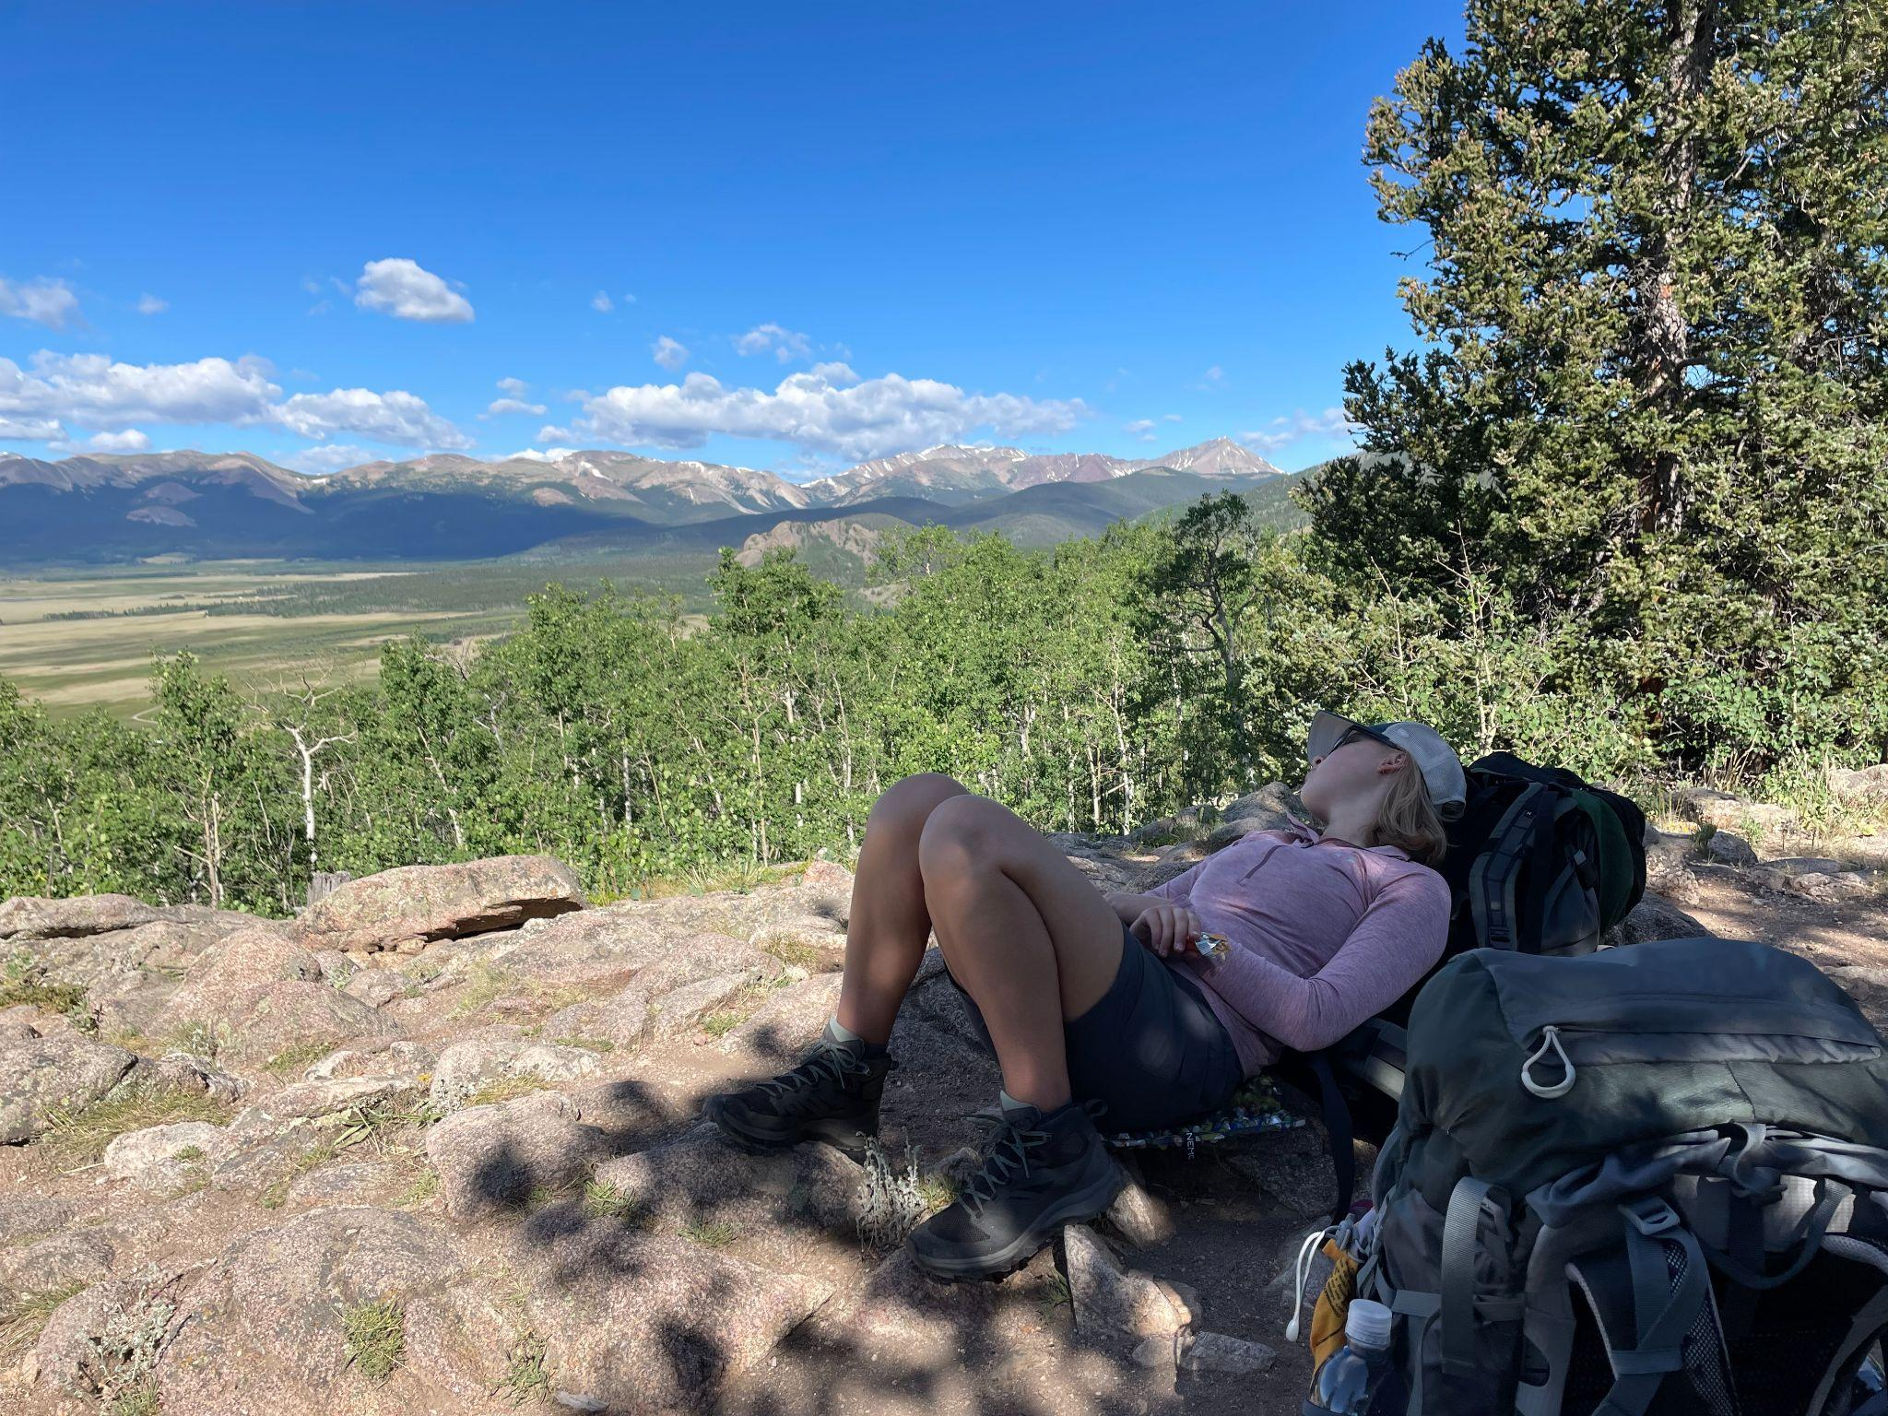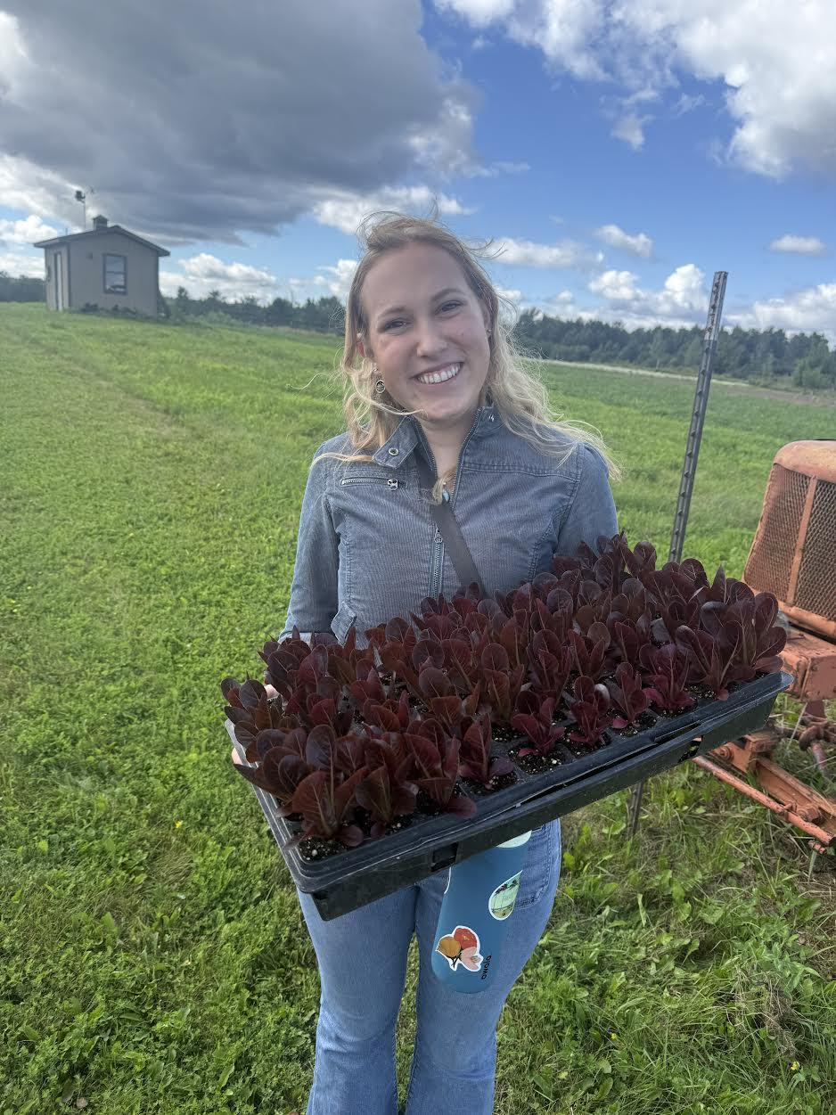

* • Personal stories and experiences related to your hobbies
* My 8th grade select choir was very important to me and the director, Seth Gregory, was one of those teachers who you never forget. He was one of those teachers who you know are there for YOU and you can always go to and count on. He made class very special, and because of that I wanted to do something for him. I got together with my classmates, and together we planned a surprise for him. We had a teacher distract him while we got to work, throwing streamers all over the room and blowing up balloons. When he walked into the classroom, we screamed, surprise! Then, the first chords of Count on Me by Bruno Mars started playing, and while we sang this song to our beloved choir director, each of us stepped up and handed him a rose. We also all had gifts and cards for him and his new baby which was on the way. I will never forget seeing the tears roll down his face and the warm feeling embracing all of us.
* • Why these activities are important to you
* Choir and theater have been a very important aspect of my life because I have made so many memories and met so many amazing people. There was a study in 2013 that found that when people sing together, their heartbeats actually synchronize. This is the perfect way to describe how choir/theater has felt for me, you feel so close to that group of people because they are your family. I have been a part of many groups over the years, and they all have a special place in my heart for different reasons.
* Swimming was another family for me, but it was a bit different because the sport pushes your mind and body in a different way. I had never considered myself to be an athletic person before I joined swimming in my freshman year of high school, but over the next three years, I was able to push myself in ways I never thought possible. There were some mornings I had to drag myself out of bed and struggled to jump into that cold water at 5:15am, but I did it over and over and over again until I was able to achieve a level of greatness within myself which I will always be proud of.

##### **3. Discover Page (UMD & Duluth)**

* • Why you chose University of Minnesota Duluth
* On the academic side, it sparked my interest that Duluth has an emphasis on research and also has a goal of creating well rounded graduates prepared to enter the workforce with the experience they need to thrive. I also have really been enjoying the sense of community here and how kind everyone is. I feel like the college does a really good job of making sure there are plenty of activities and a multitude of ways to meet people.
* • What you like about Duluth and the surrounding area  
  I love the vibe here. As someone who is really into nature, I love how many opportunities there are to escape into the forest. I also enjoy canal park and the view of the ocean, I mean lake. I enjoy the small town feel while it’s also a large town in a way. It’s the perfect blend of both.
* • 30-second UMD marketing video (Group work - entire team can use same video)
* • Personal experiences and campus highlights

##### **4. Resume Page**

* • Web-formatted version of your professional resume
* 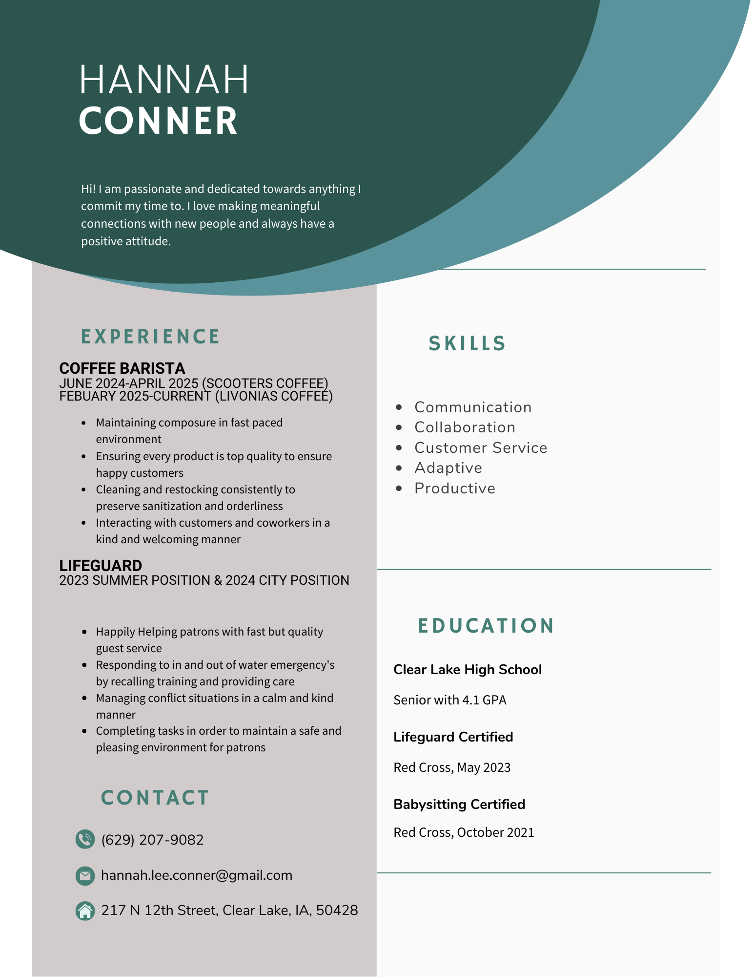
* • Download button for PDF version of resume
* <https://www.canva.com/design/DAFfG_779d0/ZOwZSpGohd5vn77f09jKnQ/edit?utm_content=DAFfG_779d0&utm_campaign=designshare&utm_medium=link2&utm_source=sharebutton>
* • Education, experience, skills, and achievements
* • Professional formatting and presentation

##### **5. Career Interests Section**

* • Two companies you're interested in working for
* Primerica is a financial services company centered around families. They offer a workplace that offers our employees a wide range of opportunities to learn, grow and thrive in their careers while also fostering an engaging environment fueled by collaboration and inclusion. They are recognized as an employer of choice for our culture and positive work environment. They offer a 6-month training program which helps you to gain license, mentorship, and experience in finance and business. This can be a stand alone course, or you can have the opportunity to be hired after completion.
* Travelers is an American insurance company providing personal, business, bond, and specialty insurance. A top 10 writer of personal insurance in the U.S., it offers coverage for various vehicles and customizable policies. They offer many positions, including corporate careers in legal, human resources, marketing, and more.

## 

* • Complete contact information for each company
* <https://www.primerica.com/public/>
* Wanda Archer (Financial Advisor)
* 333 S Wadsworth Blvd STE D-120, Lakewood, CO 80227
* (509)301-4524
* <https://www.travelers.com/>
* Dylan Olson (Associate Account Executive, Bond & Specialty Insurance, Private and Non-Private)
* [dnolson@travelers.com](mailto:dnolson@travelers.com)
* 385 Washington St, 9276-SB04R, St. Paul, MN 55102
* (651)310-2452
* • Detailed explanation of why you like that job/internship opportunity
* I am very interested in finance as well as business functions. It intrigues me that they offer the training course, which would be very useful for me whether I join their company or not.
* I want to work in a corporate level position. They offer many different opportunities within this context and I like the idea of working for a big company because that offers many opportunities for promotions.
* • What makes you qualified for these positions
* I would be prepared for this company after completion of their training program. I also have already been gaining many skills within my business classes, as well as through being a member of DECA in high school.
* I am slowly but surely growing my background of business knowledge. I also am a fast learner/very adaptable. Another thing which sets me apart is I have a very strong work ethic and don’t need to be micromanaged in order to be a successful employee/member of the company.
* • How your skills and interests align with their needs
* I believe that every company needs a psychologist for many aspects of business, so as a psychology major and business minor, I believe that my unique skills are an asset that might be rare to find in other employees who have a business focus.
* As a psychology major, this background gives me the know-how to aid this company by using my skills to improve employee wellbeing, boost productivity, and create a positive culture by applying my knowledge to workplace challenges. I also can aid in employee selection, training, motivation, and the overall efficiency, engagement, and satisfaction of the workplace environment.

##### **6. Interactive Game Page**

* • Interactive page featuring a web-based game
* • Team project - entire team creates one game together
* • All team members can use the same game on their websites
* • Game should be engaging and demonstrate JavaScript skills

Color scheme and design theme ideas:

* I really like the colors forest green and light blue
* Perhaps a more simple design, clean looking but also aesthetically appealing
* I like pictures so it would be nice to integrate a bunch of pictures into the design

Timeline:

Home Page (Complete by Oct 9th)

Hobbies Page (Complete by Oct 14th)

Discover Page (Complete by Oct 16th)

Resume Page (Complete by Oct 21st)

Career Interests (Complete by Oct 23rd)

Interactive Game Page (Complete by Oct 28th)